**Practical 7**

**(PART – A)**

|  |  |
| --- | --- |
| Roll No. A016 | Name: Varun Khadayate |
| Program: B-Tech (CSBS) | Division: SY |
| Batch: 1 | Date of Experiment: 08-09-2020 |
| Date of Submission: 08-09-2020 | Grade: |

***Aim: To develop a turing machine.***

**Outcome:** After successfully competing of this practical, students will be able to learn:

* What is turing machine?
* How it works?
* How to convert Turing machine to unrestricted grammar?

**A.1 Reading**

Read Page 70 to 102 of lab manual.

**A.2 Tasks**

1. Develop a single tape turing machine for the language L = {anbncn} for n > 0 using JFLAP tool.
2. Convert it to unrestricted grammar using JFLAP tool.

**PART B**

(PART B: TO BE COMPLETED BY STUDENTS)

**(Students must submit the soft copy as per following segments within two hours of the practical. The soft copy must be uploaded on the Portal or emailed to the concerned lab in charge faculties at the end of the practical in case the there is no portal access available)**

**B.1 Output:**

1. Write a procedure to generate the Turing machine using JFLAP tool.

* Open JFLAP tool
* Click on Single tape turing machine
* Add seven states to the screen, setting the initial state to be q0 and the final state to be q6
* Set the initial and final states
* Add a transition between the states q0 and q1
* Notice that there are three inputs instead of one.
* The value in the first box represents the current value under the head of the Turing machine. The second value is the value that will replace the first value on the tape once this step has been processed. The size of the values in these two boxes is limited to one character. The third value represents where the head will move after processing the step. It can be one of three values: 'R' (move right one square), 'L' (move left one square), and S (stay put and do not move the head)

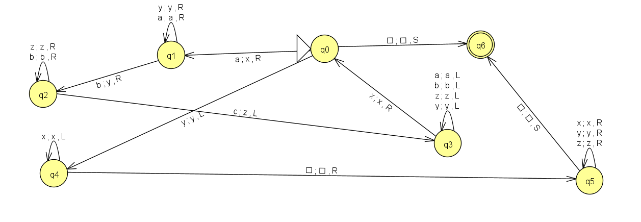

2. Write a procedure to convert turing machine to unrestricted grammar using the JFLAP tool.

* Hover to the convert option.
* Click on convert to unrestricted grammar.
* Then click on show all.

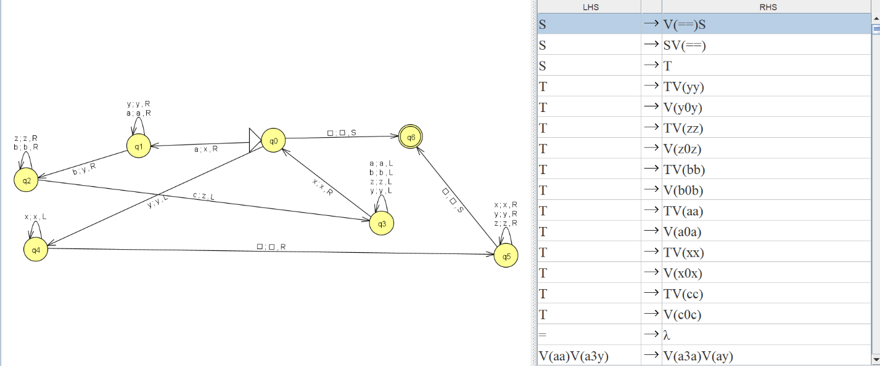

**B.2 Observations/Learning**

*(Students are supposed to write the logic of constructed DFA and generated regular expression)*

We were able to design a Turing machine for the given language and successfully convert it to unrestricted grammar.

**B.3 Conclusion:**

*(Students must write the conclusion as per the attainment of individual outcomes and learning/observation)*

The conclusion was derived from the experiment was that the Turing machine accepts the strings that contain equal number of a’s, b’s and c’s.

***B.4 Curiosity Question***

***Can you generate a general formula to find total number of states when positions of particular input is fixed from left hand side? Explain***